**Technology about Edge Computing.**

**A Seminar REPORT**

***Submitted by***

Name ID

1. Mesenbet Tenaw…………………………………………1273
2. Biruk Begashaw……………………………………….. 1251
3. Melkam Ayenaw………………………………………….1272
4. Yonas Telayneh……………………………………………..1292
5. Biruk Shewaferahu…………………………………………..1238
6. Tigist abay ……………………………………………………1285



**DEPARTMENT OF SOFTWARE ENGINEERING**

INSTITUTE OF TECHNOLOGY

**DEBREMARKOS UNIVERSITY**

DEBRE MARKOS, ETHIOPIA

March 2014

Table of Contents

[**CHAPTER 1** 1](#_Toc99015181)

[**1.** **Edge Computing** 1](#_Toc99015182)

[**1.1** **Introduction** 1](#_Toc99015183)

[**1.2** **History of Edge Computing** 2](#_Toc99015184)

[**1.3** **Why Edge Computing Develop** 2](#_Toc99015185)

[**1.4** **Application of Edge Computing** 2](#_Toc99015186)

[**1.5** **Challenges’ of Edge Computing** 7](#_Toc99015187)

[**Reference** 8](#_Toc99015188)

[**Figure 1 IOT Devices** 3](#_Toc99015204)

[**Figure 2 Edge computing in Agriculture** 5](#_Toc99015205)

[**Figure 3 Edge computing on conference** 6](#_Toc99015206)

# **CHAPTER 1**

# **Edge Computing**

## **Introduction**

Edge computing is the modern, distributed computing architecture that brings data storage and computation closer to the data source. This helps save [bandwidth](https://geekflare.com/bandwidth-calculator-tools/) and improve the response time.

**Edge computing** is the computational processing of sensor data away from the centralized nodes and close to the logical edge of the network, toward individual sources of data. It creates a new kind of approach to the network architecture. It is the deployment of computing and storage resources at the location where data is produced.

Simply put, edge computing involves fewer processes running in the cloud. It also moves those computing processes to edge devices, such as [IoT devices](https://geekflare.com/iot-for-beginners/" \t "_blank), edge servers, or users’ computers. This way of bringing computation closer or at the network’s edge reduces long-distance communication between a server and a client. Therefore, it reduces bandwidth usage and [latency](https://geekflare.com/intro-latency-bandwidth-througput/).

Edge computing is essentially an architecture instead of a technology per se. It is location-specific computing that doesn’t rely on the cloud to perform the work. However, it never means that the cloud won’t exist; it just becomes closer. [1]

Edge computing originated as a concept in content delivery networks (CDNs) created in the 1990s to deliver video and web content using edge servers deployed closer to the users. In the 2000s, those networks evolved and started hosting apps and app components directly at the edge servers.

## **History of Edge Computing**

Edge computing is gaining more and more popularity in the IoT domain. In 2018, it was one of the [top technology trends](https://www.gartner.com/smarterwithgartner/gartner-top-10-strategic-technology-trends-for-2018/) forming the foundation for the next generation of digital businesses. In parallel, given the massive amounts of data and the need to optimize computational resources, we are also seeing an increasing tendency to send data to the cloud.

The origin of edge computing can be traced back to the **1990s** when Akamai launched its **content delivery network (CDN)**. The idea back then was to introduce nodes at locations geographically closer to the end-user for the delivery of cached content such as images and videos. [2]

## **Why Edge Computing Develop**

Edge computing was developed **due to the exponential growth of IoT devices**, which connect to the internet for either receiving information from the cloud or delivering data back to the cloud. And many IoT devices generate enormous amounts of data during their operations.

## **Application of Edge Computing**

Edge computing finds applications in various industries. It is used to aggregate, process, filter, and analyze data near or at the network edge. Some of the areas where it is applied are:

**IoT Devices**

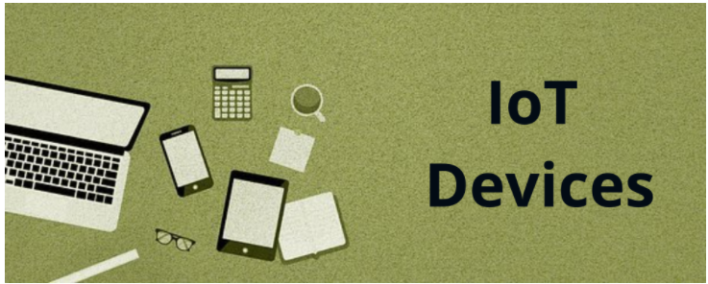

**Figure 1 IOT Devices**

It’s a common misconception that edge computing and IoT are the same. In reality, edge computing is an architecture, whereas [IoT is a technology](https://geekflare.com/iot-for-beginners/) that uses edge computing.

Smart devices like smartphones, smart thermostats, smart vehicles, smart locks, [smart watches](https://geekflare.com/best-kids-smart-watch/), etc., connect to the internet and benefit from code running on those devices themselves instead of the cloud for efficient use.

**Optimizin g Network**

Edge computing helps optimize the network by measuring and improving its performance across the web for users. It finds a network path with the lowest latency and most reliability for user traffic. In addition, it can also clear out traffic congestion for optimal performance.

**Healthcare**

A vast amount of data is generated from the healthcare industry. It involves patient data from medical equipment, sensors, and devices.

Therefore, there is a greater need to manage, process, and store the data. Edge computing helps here by applying [machine learning](https://geekflare.com/getting-started-with-machine-learning/) and automation for data access. It helps identify problematic data that requires immediate attention by clinicians to enable better patient care and eliminate health incidents.

In addition, edge computing is used in medical monitoring systems to respond quickly in real-time instead of waiting for a cloud server to act.

**Retail**

Retail businesses also generate large chunks of data from stock tracking, sales, surveillance, and other business information. Using edge computing enables people to collect and analyze this data and find business opportunities like sales prediction, optimizing vendor orders, conducting effective campaigns, and more.

**Manufacturing**

Edge computing is used in the manufacturing sector to monitor manufacturing processes and apply machine learning and real-time analytics to improve product qualities and detect production errors. It also supports the environmental sensors to be incorporated in manufacturing plants.

Furthermore, edge computing provides insights into the components in stock and how long they would go. It helps the manufacturer to make accurate and faster business decisions on operations and the factory.

**Construction**

The construction industry uses edge computing mainly for workplace safety to collect and analyze data taken from safety devices, cameras, sensors, etc. It helps businesses overview workplace safety conditions and ensures that employees are following safety protocols.

**Transportation**

The transportation sector, especially autonomous vehicles, produces terabytes of data every day. Autonomous vehicles need data to be collected and analyzed while they are moving, in real-time, which requires heavy computing. They also need data on vehicle condition, speed, location, road and traffic conditions, and nearby vehicles.

To handle this, the vehicles themselves become the edge where the computing takes place. As a result, data is processed at an accelerated speed to fuel the data collection and analysis needs.

**Agriculture**

**Figure 2 Edge computing in Agriculture**

In farming, edge computing is utilized in sensors to track nutrient density and water usage and optimize the harvest. For this, the sensor collects data on environmental, temperature, and soil conditions. It analyzes their effects to help enhance the crop yield and ensure they are harvested during the most favorable environmental conditions.

**Energy**

Edge computing is useful in the energy sector as well to monitor safety with gas and oil utilities. Sensors monitor the humidity and pressure continuously. Additionally, it must not lose connectivity because if something wrong happens, like an overheating oil pipe goes undetected, it can lead to disasters. The challenge is that most of those facilities are situated in remote areas, where connectivity is poor.

Hence, deploying edge computing at those systems or near them offers greater connectivity and continuous monitoring capabilities. Edge computing can also determine real-time equipment malfunctions. The sensors can monitor energy generated by all the machines such as electric vehicles, wind farm systems, and more with grid control to help in cost reduction and efficient energy generation.

Other edge computing applications are for video conferencing that consumes large bandwidths, efficient caching with code running on CDN edge networks, financial services such as banks for security, and more. [1]

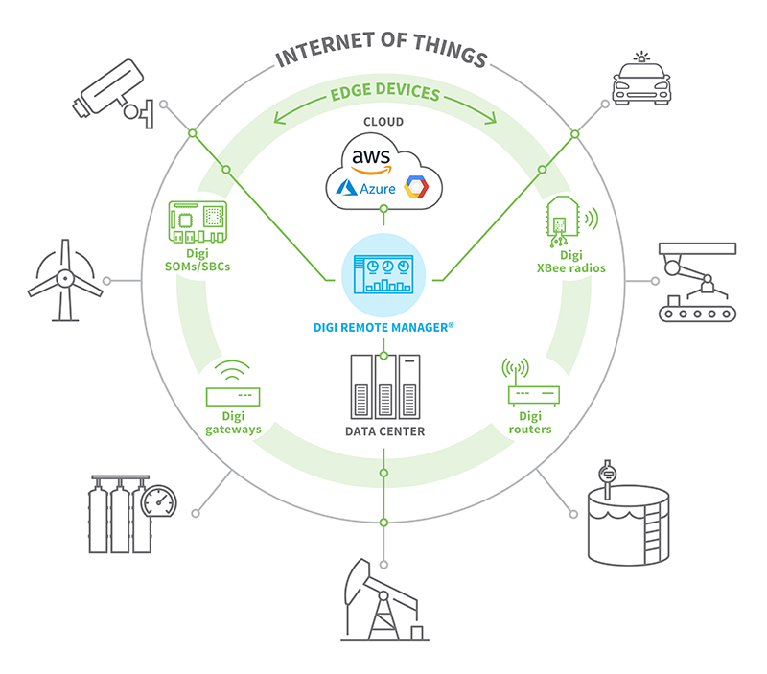

**Figure 3 Edge computing on conference**

## **Challenges’ of Edge Computing**

The advancement of the Internet of Things (IoT) and Cloud Computing have pushed the horizon for a new paradigm in computer science that calls for processing the data at edge networks – i.e., edge computing. Edge Computing essentially takes memory and computing out of traditional data centers to bring them as close as possible to the location where they are needed, like mobile phone devices, tablets, wireless earphones, etc.

This technology has the potential to provide a reasonable computation platform when compared to the cloud, thus enhancing battery life, data safety, and privacy. However, integrating edge computing into other sectors is not void of challenges.

There are still a few major challenges that need to be overcome to make edge computing efficient, stable, and user-friendly. [3]

**Network Bandwidth**

In traditional networks, enterprises would allocate higher bandwidth at central data centers and lower bandwidth to the endpoints. Whereas, in an edge computing server, more bandwidth is required across all individual ends of the server. This creates a need for more bandwidth when compared to traditional networks.

**Distributed Computing**

In most of the servers, the set of modules is placed far apart from each other in a distributive manner. Whereas, edge computing tends to bring all the systems closer to the computational areas. This creates a conflict as the business server needs to consider the edge server as an additional aspect during computation.

**Latency**

Latency is essentially the delay caused by data transmission. In an edge server, if the computation is taking place closer to data or if the compute is only happening at the center, latency can be reduced. But usually, due to distributive computing and both-ways computation, latency issues occur.

**Security and Encryption**

Each device in an edge server represents another potentially vulnerable endpoint, and the internet of things (IoT) is notorious for its lack of robust security. Also, smaller data centers like embedded devices are not designed by security measures and aren’t updated as often as they should be.

**Operational Constraints**

Due to multiple edge receivers placed at certain distances from the data center, troubleshooting, and repair of any issue that occurred in the framework need a lot of logistic as well as manual input hence increasing the cost of maintenance.

# **Reference**

**[1].** [**https://geekflare.com/edge-computing-and-its-applications/**](https://geekflare.com/edge-computing-and-its-applications/)

**[2],** [**https://blog.bosch-si.com/bosch-iot-suite/cloud-and-edge-computing-for-iot-a-short-history/**](https://blog.bosch-si.com/bosch-iot-suite/cloud-and-edge-computing-for-iot-a-short-history/)

**[3],** [**https://www.greyb.com/edge-computing-challenges-and-their-solutions/**](https://www.greyb.com/edge-computing-challenges-and-their-solutions/)